**GitHub-**

Create the central repository on GitHub.

**Git-**

Install Git on your local machine by “git init” command to create the local repository.

Or

Git clone or clone your repository from GitHub.

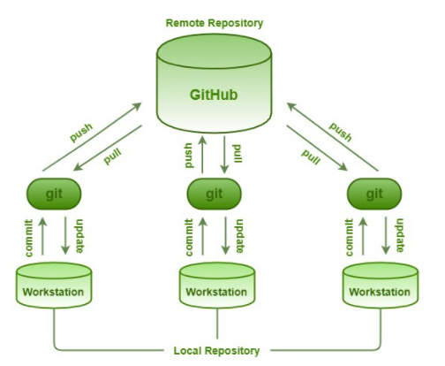

Note-

1. Repository name should be unique.
2. Select type as private or public.
3. Click on create repositories

**Create repositories-**

Try to create the local repositories for that you need to install Git on machine

Go to system folder->where you create the repositories.

Right click->Git base here then it it will open the command prompt

Type git init on that command and press enter

**Sync repositories-**

How to copy the url(Go to GitHub site, click on clone or download button, copy that URL.

How to copy the files from remote repository to local repository by using below command

git pull origin master

now the files has been added to your local repositories.

Then next time onwards.

If you want to get the changes from central repository then use

git push origin master-

It will copy changes from local repository to remote repository.

so automatically it will retrieve the data from central repository. So you will get the latest code then after make the changes in your local repository then use command git push to commit the changes to remote repository.

**Making the changes-**

Git status- this will display list of files which are added to local repository

Git add- add the files to your index.

🡪git add filename is suppose login.java

Git commit- commit the changes to repository

🡪git commit –m “login method change” and press enter. Used to commit the changes into local repository

🡪git log- to check the history

**Parallel development-**

**How to create the new branch**

git branch rambranch

--this will contain all data of master branch because its originated from master branch.

If you want to move from one branch to another branch that is called as checking out.

git branch checkout master

Now this will points to your branch not master.

Starts write the code then

git add sample

git commit

🡪points to master branch then type

git merge rambranch (branch name)

* git push- copy the changes from local to remote repository
* git pull- copy or fetch the changes from remote to local repository